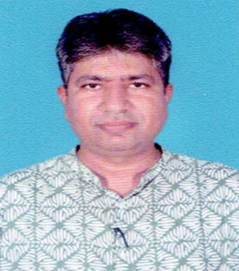 | Name | Dr. Nirajkumar D. Mehta
 | Date of Birth | 06/12/1980
 | Teacher Code | AYDG00102
 | Registration | GBI 14853
 | Qualification | MD (Ayu
 | Designation | Principal / Professor (Dravyaguna Vigyana)
 | Date of Joining | 25/07/2023
 | Experience | 19 Yrs.
 | Contact No. | 9998854392
 | Email Id | drnirajdm@gmail.com

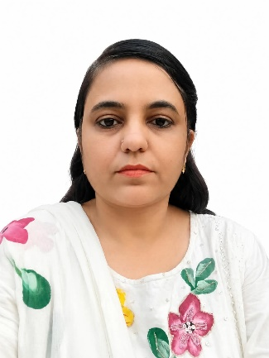 | Name | Dr Ekata K. Yadav
 | Designation | Associate Professor
 | Department | Dravyaguna Vigyana
 | Qualification | MD (Ayu)
 | Teacher Code | AYDG01526
 | Experience | 5.5 Years
 | Date of Birth | 12/06/1986
 | Date of Joining | 01/09/2026
 | Registration Number | GB I-17850
 | Mobile No. | 9978414790
 | Email Id: | drekata1@gmail.com

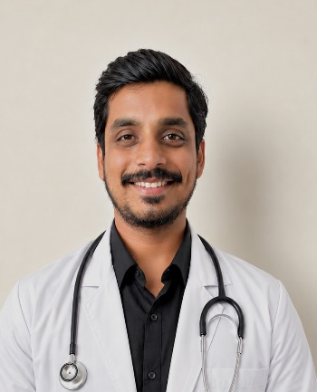 | Name | Dr. Sahil H. Bhavsar
 | Designation | Assistant Professor
 | Department | Dravyaguna Vigyana
 | Qualification | MD (Ayu)
 | Teacher Code | AYDG02124
 | Experience | 1.5 Years
 | Date of Birth | 16/06/1998
 | Date of Joining | 01/10/2025
 | Registration Number | 23140
 | Mobile No. | 9898417304
 | Email Id: | shbhavsar16698@gmail.com

