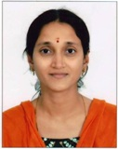 | Name | Dr Rukmini K. Patel
 | Designation | Professor
 | Department | Rasa Shastra & Bhaisajya Kalpana
 | Qualification | MD (Ayu)
 | Teacher Code | AYRB00368
 | Experience | 14.5 Years
 | Date of Birth | 24/08/1973
 | Date of Joining | 02/09/2026
 | Registration Number | GBI 20489
 | Mobile No. | 9409639226
 | Email Id: | kotirukminibai1974@gmail.com

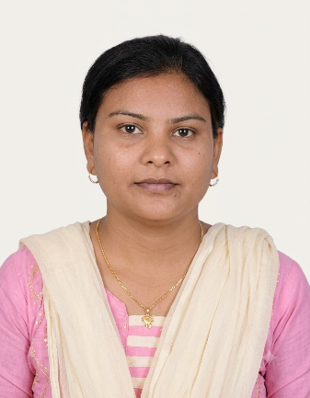 | Name | Dr. Rejoice N. Macwan
 | Designation | Associate Professor
 | Department | Rasa Shastra & Bhaisajya Kalpana
 | Qualification | MD (Ayu)
 | Teacher Code | AYRB00608
 | Experience | 8.5 Years
 | Date of Birth | 05/11/1982
 | Date of Joining | 27/11/2025
 | Registration Number | GB I 15374
 | Mobile No. | 9428491999
 | Email Id: | joyforever777@gmail.com

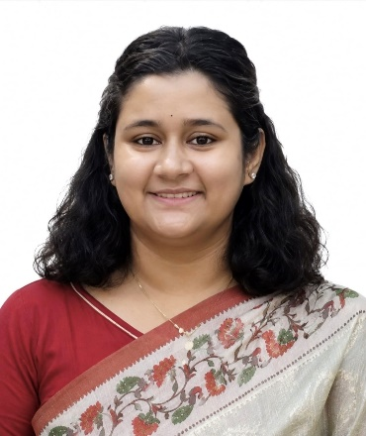 | Name | Dr Samarpita Bhattacarjee
 | Designation | Assistant Professor
 | Department | Rasa Shastra & Bhaisajya Kalpana
 | Qualification | MD (Ayu)
 | Teacher Code | AYRB01753
 | Experience | 4.5Years
 | Date of Birth | 12/08/1991
 | Date of Joining | 14/11/2025
 | Registration Number | 12311
 | Mobile No. | 8131837367
 | Email Id: | Samarpitab3@gmail.com

