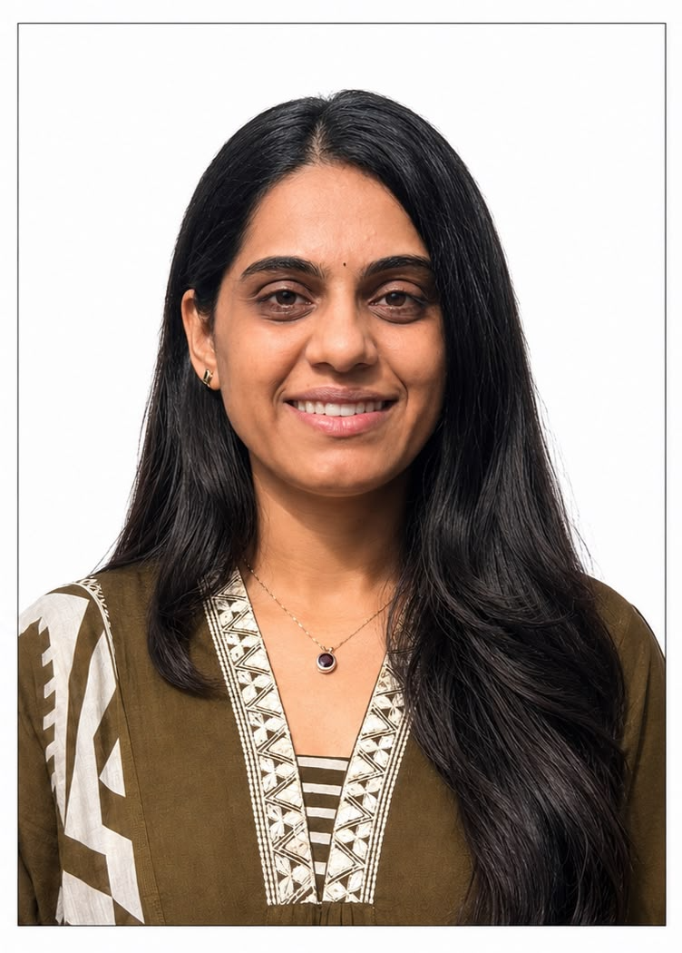 | Name | Dr Dharvi V Thakkar
 | Designation | Assistant Professor
 | Department | Ayurved Samhita & Siddhant
 | Qualification | MD (Ayu)
 | Teacher Code | AYSS02048
 | Experience | 2.5 Years
 | Date of Birth | 15/03/1996
 | Date of Joining | 09/08/2025
 | Registration Number | GBI21791
 | Mobile No. | 7698869596
 | Email Id: | dharvithakkar153@gmail.com

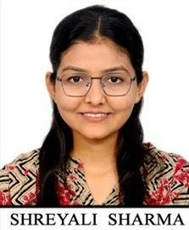 | Name | Dr Shreyali R. Sharma
 | Designation | Assistant Professor
 | Department | Ayurved Samhita & Siddhant
 | Qualification | MD (Ayu)
 | Teacher Code | AYSS02481
 | Experience | Less than 1 Year
 | Date of Birth | 09/04/1998
 | Date of Joining | 16/05/2026
 | Registration Number | GBI-23886
 | Mobile No. | 7600840885
 | Email Id: | shreyali.1137@gmail.com

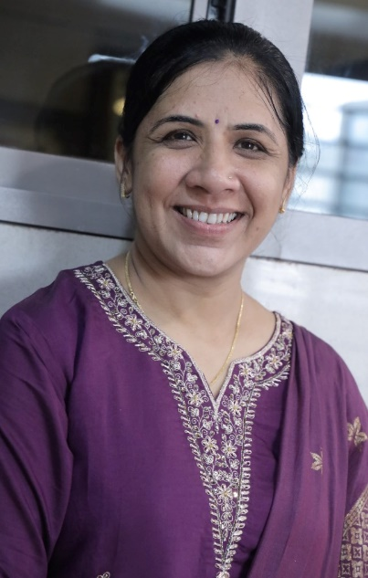 | Name | Dr Nishaben L. Vegda
 | Designation | Assistant Professor (Sanskrit Teacher)
 | Department | Ayurved Samhita Siddhant & Sanskrit
 | Qualification | PhD (Sanskrit)
 | Teacher Code | AYSN0715
 | Experience | 3.3 Years
 | Date of Birth | 30/03/1986
 | Date of Joining | 02/07/2026
 | Registration Number | N/A
 | Mobile No. | 9428740255
 | Email Id: | nishavegda30@gmail.com

